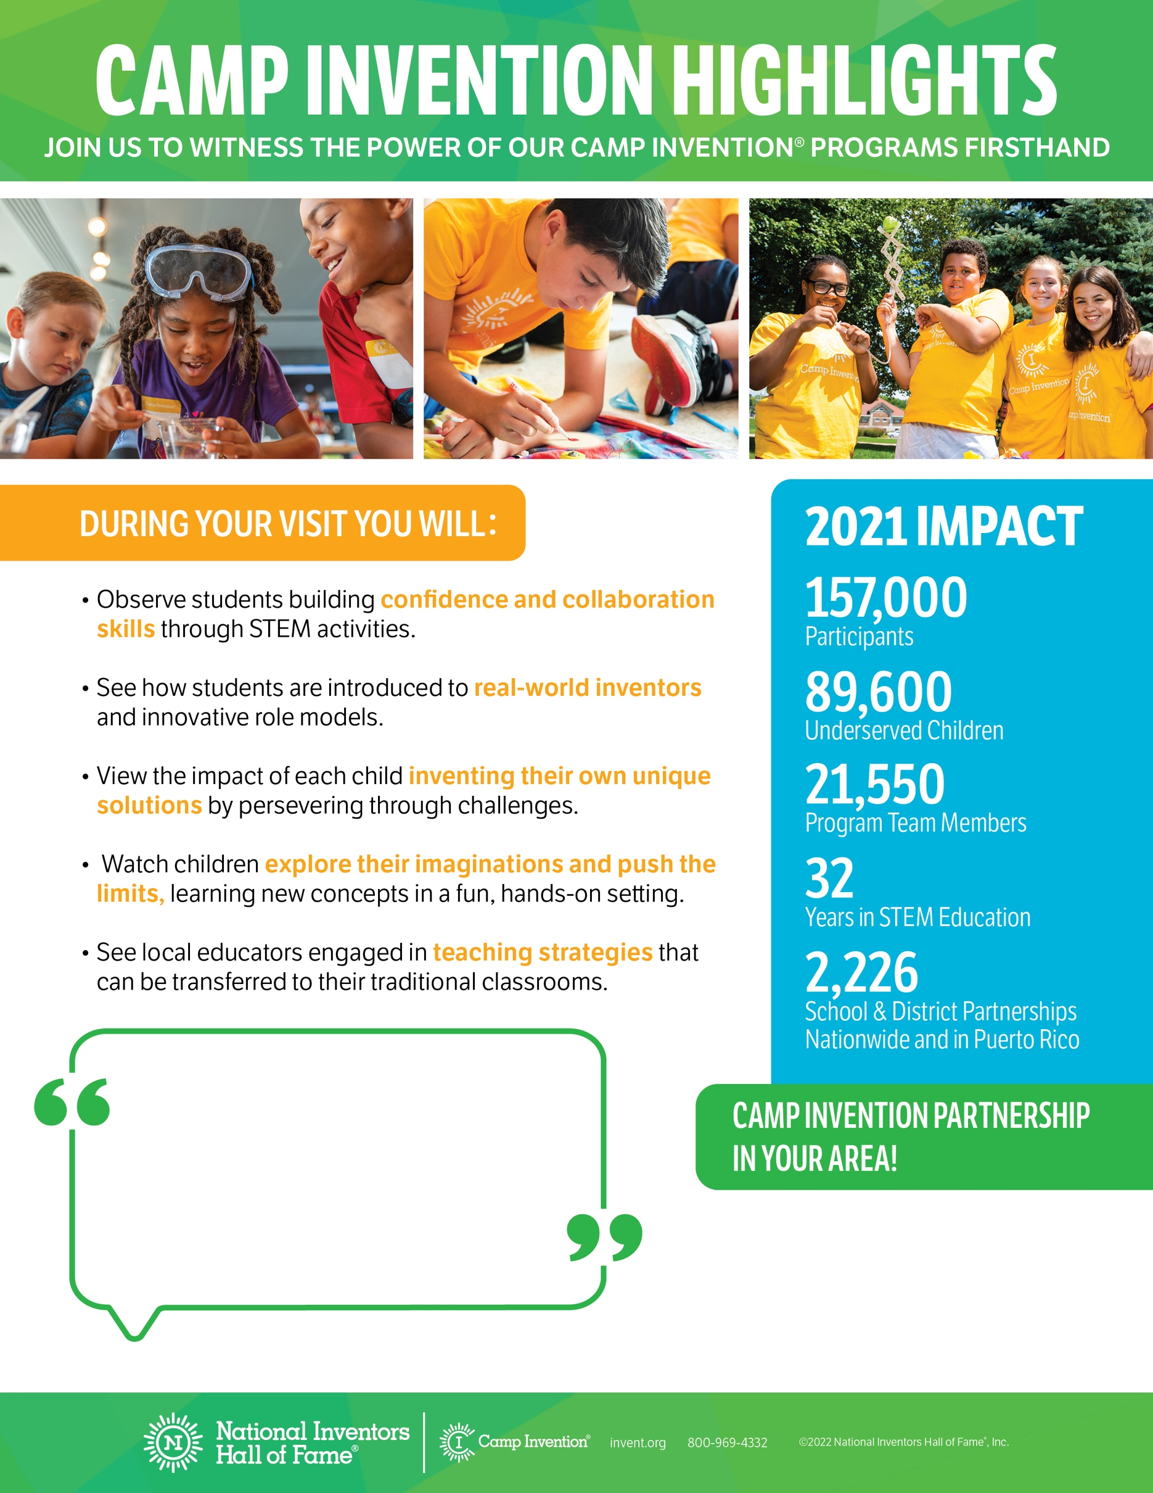­

Here is where the partnership info will go

**–** Replace with who said the quote

Replace with quote.