How to Build Buzz About Camp Invention on Facebook!

We have three solid tips for you on how to spread the word after creating your Camp Invention® Event page on Facebook.

1) Invite Friends

Step A: After the event has been created, click on the “Invite” button shown below and select the option “Choose Friends.”

Step B: A list of all your Facebook friends will appear.

Step C: We suggest clicking on any of your friends with children, grandchildren, nephews or nieces who are old enough to attend Camp Invention and live within driving distance of the host site. They’ll be happy to learn about the program and its presence in your community. Also, send it to friends who are active on social because they will love to spread the word!
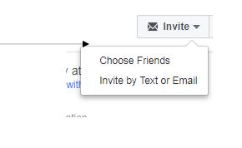
2) Share Event

Step A: Click on the “Share” button. You will see these options: “Share in Messenger” and “Share in Newsfeed.”

Step B: You can now share the event on your own Facebook timeline, on a friend’s timeline, in a group where you’re active or on a Facebook page you manage.

Step C: Another option is to private message a friend letting them know about the event through Facebook Messenger, but we suggest publicly promoting the event rather than privately.
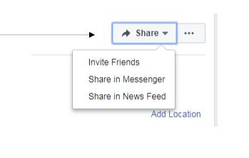

3) Email/Share the URL

You can copy the URL of the Facebook event and email it to the host school and other local organizations that would be willing to share the event on their Facebook page as their own post. Although the URL might seem long, you can assure them that once it is typed into the Status Box (where you would share a status or photo), a preview will appear, and then the long URL can be deleted.

Step A: Copy the information in this box:

Step B: Next, paste the URL into the Status Box and the preview of the event information will automatically appear:

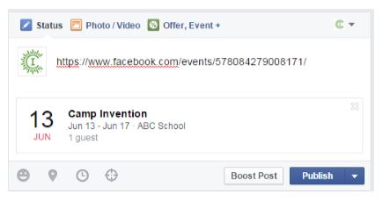

Step C: Once the preview box appears, delete the long URL (the preview box will remain intact), replace it with a message inviting people to learn more and click “Post.”

Social Media Best Practices

After you have created your Camp Invention Event page, and you have invited and shared it with all your friends in the local area, incorporate these five best practice tips to ensure your Event page is a success. After all, for many people this page will be their first impression of Camp Invention. Let’s make it a good one!

1) Always Respond
While social media has brought the world into the palm of people’s hands, people still use this platform for one-on-one, human interaction. Therefore, whenever a camp parent posts on your Event page’s timeline, comments on a picture or sends a private message, it is of utmost importance that you respond in a timely manner (within 48 hours).

- Always comment on and “like” comments, pictures or any other post that a parent might share.
- If a parent asks a question publicly or privately, always answer to the best of your ability. If it is a question that you do not know the answer to, suggest that they contact Camp Invention’s Customer Relations Team at 800-968-4332, and visit our Parent Resource Center: http://campinvention.org/inspire/camp-invention-k-6th/parent-resource-center/.
- Please share any complaints with the Customer Relations Team by calling 800-968-4332.

2) Share Camp Invention Facebook Page Content
The Camp Invention page will share numerous promo codes and program information throughout the year. You should share this content on your Event page because it presents an excellent opportunity to drive traffic to your page and increase enrollment! It is also a best practice to personally share the post and direct people to your Camp Invention Event page, where they can learn more about camp and register their child!

3) Use the Content we provide in the Resource Center
Posts: Located in the “SocialMedia2019_Supercharged_Content” and “SocialMedia2019_Epic,Create,Launch_Content” documents are prewritten posts for your convenience. Simply enter your camp location and dates to customize the copy. This text is also perfect to use when you share the event publicly on your timeline, with your friends or on group pages!

Banners: Located in the Program Resource Center are several Camp Invention banners that were designed by our creative department. Not only are they high-quality and the correct banner image size, they are great for branding your event. Use your favorite one, or switch between them to keep your event fresh!

Images: Also located in the Program Resource Center are a select group of images that can be found in the “Camp Invention Social Post Images” folder. We have prepared text that corresponds to the images; this can be found in the “SocialMedia_Images-and-Text” document. We suggest you mix these image posts in with the posts listed in the “Social Media Content _Elevate” and “Social Media Content - Epic, Launch, FastForward” documents.

4) Does your Camp Invention location offer scholarships? If yes, promote it!
This one is simple! If your location supplies scholarships, that is exciting information to share. It also catches the eyes of parents who might have initially been priced out of Camp Invention. We strongly suggest you share this publicly, outside of your event, as well. Be sure to include any details on the scholarships available, such as the total number available or if they must register by a specific date to be eligible, so potential attendees understand limitations.

5) Share pictures during Camp, and within a week after Camp Invention ends!
Parents want to see their kids having fun! Update your Event page with pictures of campers participating in the activities and when camp is over, post a collection of images for parents to view. This simple step goes a long way with parents of campers. (Note: Be sure to only take photos if the child has a photo release form.)

