Why You Should Create a Facebook Event for Your Local Camp Invention

Creating an event for your local Camp Invention® program, rather than a profile or company page, is MUCH more beneficial to your camp for numerous reasons:

- Communicating to Parents:
  - When a parent selects “Attending” on the event page, he or she will receive notifications every time there is an update on the event page. This means every time you post a status update, logistical change, share a promotion code or upload pictures taken that day, this information will show in every parent’s newsfeeds and alert them to check the event page.
    - This does not happen with a Facebook page. Only a fraction of followers will see updates from pages, so keep in mind any urgent or time-sensitive issues will not be seen by all camp parents!

- Time Management:
  - Creating and maintaining an event is easy. In the next section, we have a step-by-step guide detailing how to create one.
  - We also have prepared numerous posts and graphics for your use. These can be found in the “Social Media” folder in the online resource center.
  - Events also can be taken down from Facebook a few weeks after Camp Invention is over. With a Facebook page, you are required to maintain the page year-round, as any inquiries must be answered.

- A Camp Invention Page Already Exists:
  - We have a dedicated team of social media professionals to maintain our social profiles. Through advertising campaigns and responding to parent questions year-round, they are always working to boost your camp registration!

Creating an Event on Facebook
A Step-by-Step Guide

Now that you understand the numerous benefits that Facebook events offer, follow the detailed steps below to create your own!

1) Find the “Explore” section on the left side of your personal Facebook page. Click on “Events.” (Note: The additional options shown below might appear in a different order or some options might not appear at all.)

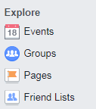

2) On the events page, click on “+ Create Event” and select “Create Public Event.”

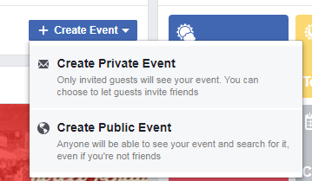

3) Complete the fields in this box with the information below.

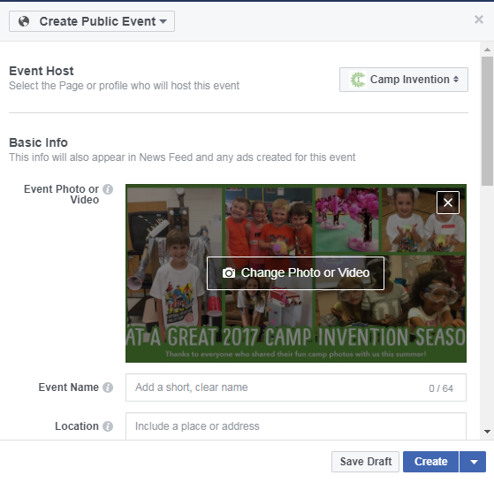

4) We have created a variety of banner photos for you to choose from and use on your event page. They are in the “Social Media” folder in the online resource center. Please download these photos to use on your event page.

5) Event name should be “Camp Invention – [Your Location’s Name]”

6) In the “Location” section, post the name of the site where the program is taking place, and link to the school’s Facebook page if applicable.

7) Set the start day/time for when participants are to arrive at camp on the first day. The end day/time should be the final day and ending time of camp.

Continue filling out the form.

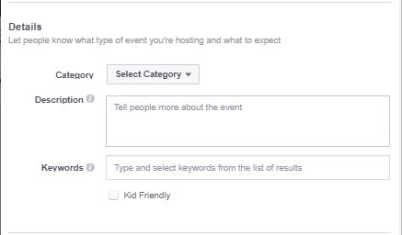

8) Select “Other” for your event’s category.

9) Include keywords such as “Camp,” “Summer Camp,” “Education,” “STEM,” “Camp Invention.”

10) Below is the language we ask you to use in the description section. Please use the corresponding text for the program you are running.

Elevate copy:
In partnership with the National Inventors Hall of Fame® (NIHF), [School District Name] is pleased to offer the nationally acclaimed Camp Invention® program to children entering kindergarten through sixth grade. This exciting, weeklong summer adventure provides lessons that explore connections between science, technology, engineering and innovation. Children rotate through several hands-on activities each day while using teamwork, creative thinking and problem-solving skills to invent unique solutions to real-world challenges. The week begins on [Start Date] with [Director Name] serving as director of the all-new 2020 program, Elevate!

During this program, young innovators will:
- Build a cityscape out of upcycled materials, navigate planes through a storm and take apart a robot they’ll bring home at the end of the program.
- Learn the value of their creativity as they sketch and build prototypes, design logos, market their invention and protect their intellectual property.
- Collaborate and discover solutions to protect the Earth’s ecosystems as they compete in zipline races, explore energy conservation and help wildlife habitats.
- Discover the great inventors behind their favorite sports, play high-energy games and design the ultimate sports complex.

Camp Invention’s activities give participants the opportunity to explore, create and build confidence as they bring their biggest ideas to life.

Local educators facilitate the program and enthusiastic high school students serve as Leadership Interns, ensuring that one staff member is in place for every eight children.
RSVP to our Facebook event, but make sure to register by calling 800-968-4332 or visiting invent.org/camp, too! The cost for the weeklong program is [Cost].

Fast Forward copy:
In partnership with the National Inventors Hall of Fame® (NIHF), [School District Name] is pleased to offer the nationally acclaimed Camp Invention® program to children entering kindergarten through sixth grade. This exciting, weeklong summer adventure provides lessons that explore connections between science, technology, engineering and innovation. Children rotate through several hands-on activities each day while using teamwork, creative thinking and problem-solving skills to invent unique solutions to real-world challenges. The week begins on [Start Date] with [Director Name] serving as Director of program, Fast Forward!

During this program:
- Children receive small boxes to build their house’s structure, then get to work designing their smart home, and build models of smart gadgets and gizmos.
- Campers become robotic pet veterinarians and receive their very own robotic dog that they get to personalize and bring home.
- Children explore sensors by experimenting with their own Optibot™—a small driving bot that senses changes in dark and light surfaces, and then design a futuristic vehicle that might one day be reality.
- Campers receive new challenges each day that inspire them to think big, be bold and never give up.

Camp Invention’s activities give participants the opportunity to explore, create and build confidence as they bring their biggest ideas to life.

Local educators facilitate the program and enthusiastic high school students serve as Leadership Interns, ensuring that one staff member is in place for every eight children.

RSVP to our Facebook event, but make sure to register by calling 800-968-4332 or visiting invent.org/camp, too! The cost for the weeklong program is [Cost].

Launch copy:
In partnership with the National Inventors Hall of Fame® (NIHF), [School District Name] is pleased to offer the nationally acclaimed Camp Invention® program to children entering kindergarten through sixth grade. This exciting, weeklong summer adventure provides lessons that explore connections between science, technology, engineering and innovation. Children rotate through several hands-on activities each day while using teamwork, creative thinking and problem-solving skills to invent unique solutions to real-world challenges. The week begins on [Start Date] with [Director Name] serving as director of the Launch program!

During this program:
- As DIY duct tape experts, children design duct tape accessories and then put their own patented
spin on them as they take their creations to market!
- Teams compete in friendly air battles and use physics as they build “snowball” launchers, make a giant air cannon, launch water rockets and fling rubber chickens.
- Campers will venture on a mission to locate and prepare a new planet for habitation and set up a Space Lab to hatch eggs, sprout living plants and grow crystals.
- Children take apart machines and devices and use their parts and pieces to create the ultimate
Spy Gadget Alarm Boxes to help millions of children keep their treasures secure.

Camp Invention’s activities give participants the opportunity to explore, create and build confidence as they bring their biggest ideas to life.

Local educators facilitate the program and enthusiastic high school students serve as Leadership Interns, ensuring that one staff member is in place for every eight children.

RSVP to our Facebook event, but make sure to register by calling 800-968-4332 or visiting invent.org/camp, too! The cost for the weeklong program is [Cost].

Epic Specific Copy:
[School/District Name] is partnering with the National Inventors Hall of Fame® to provide Camp Invention®. This leading elementary summer enrichment program with a science, technology, engineering and math (STEM) focus for children in our community takes place [camp dates].

Camp Invention gives children the opportunity to take risks, use creative problem solving and develop an entrepreneurial mindset in fun and challenging ways. During this weeklong adventure, children entering grades K-6 will design and build their own inventions, take gadgets apart, be part of a team and have FUN!

Local certified educators lead a week of hands-on activities that fuel children’s confidence in their natural ability to dream and create. Team member-to-child ratios for this program are 1:8, and the size of the program accommodates 35 to 120 participants.

In the Epic program, children will participate in four fun-filled modules each day:
During this program, young innovators will:
- Explore circuitry as they make and adopt a robotic cricket fueled by a solar cell.
- Sketch out their best blueprints and clean, green-energy designs that will win over an investor for the chance to be Epic Park co-owners and operators, all while exploring principles of entrepreneurship and physics.
- Turn their creative imaginations into epic creations using upcycle materials, gears, motors, magnets and other gadgetry as they develop their own patent-worthy prototypes.
- See themselves as scientists, programmers and biologists testing out more than a dozen experiments in the Camp Invention laboratories as they program and code, create magnetic slime and complete circuits!

RSVP to our Facebook event, but make sure to register by calling 800-968-4332 or visiting invent.org/camp, too! The cost for the weeklong program is [Cost].

Dates are [Start date] to [End date] and the program runs from [Start time] to [End time].

PLEASE NOTE: The above content can be modified depending on the individual camp.

Continue filling out the form.
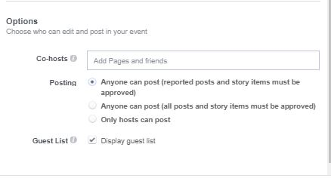

11) If you would like to share the responsibility of managing the event page with another program team member such as a co-director or instructor, you can select them to be a co-host.

IMPORTANT: This can be very beneficial as questions and inquiries can be addressed faster with two people managing the event page.

12) It is your choice whether you would like to allow anyone to post with or without your approval. However, we recommend selecting one of the first two options, as audience participation will increase event page views.

PLEASE NOTE: Public and private questions, comments or concerns must always be answered in a timely manner. We ask that you always like and comment on the posts. This improves parent experiences substantially.

13) Click “Create!”

14) Visit the resource center and read the “How to Build Buzz” document to learn about the best ways to spread the word about Camp Invention and increase your registration numbers!

